Introduction
Secure, stable, and performant Kubernetes clusters by controlling imaging

As systems need to become more reliable while increasing in complexity, a self-organizing machine with the ability to be monitored intersecting its decision-making process is a strong solution.
Dr. Christopher A. Tucker
Cartheur Research, B.V.
Emotional health and well-being is fostered by a purposeful exchange between two individuals. In an era of increasing loneliness, alienation, deconstruction, and solitude, the current technological landscape is favorable to allow the creation of artificial friends in the non-human form of emotional animals.
This white paper describes an idea for manufactured products centered on state-of-the-art techniques in artificial intelligence and robotics to create a plush interactive toy for children, adults, and the elderly, which contains the essentials of IoT while distinguishing itself among others in the marketplace by its ability to be private and secure. These emotional toys do not contain the technical constructs to connect to cloud services or the Internet, although there is the ability to connect over Bluetooth for backup and recovery.
Cartheur brings innovations in the hope of improving the range of empathetically-powered programs to improve mental health, increase social interaction, and deliver emotional satisfaction.
© The Cartheur Company, November 2022, v1.0
Throughout the course of human history, people have been reliant upon their feelings to aid them in navigating a complicated world. This has never been more apparent than in social context with our fellow humans. Feelings such as love, prejudice, happiness, worry, friendship, and trepidation have evolved along with our physical appearance. They are central to mental health and facilitator of our intercommunication.
In the current technological era, individuals interact with many types of personalities in various social platforms on devices, which are separate and distinct from the physical world. As the sophistication of technology and manufacture evolves, these devices decrease in size and price while retaining sufficient power to be the basis of an emotionally-aware robotic platform consisting of physical as well as vocal and non-verbal cues from the user.
The product, informally called an animal, is a disembodied form of a guise. A guise is a template personality, including mood, emotion, and empathy, which is configurable to an embodied form with a finite set of functional behaviors designed in which are to be expected by the user. For example, forms like an interactive teddy bear or furry cat come to bear what is expected by how they look and the feelings they project. Custom designs are also possible.
The driving ambition in this product is to support the human need for companionship and communication in an era of increasing isolation in technical devices. It also is the introduction of a means to tailor a given perception of reality as a mode of positive feedback to improve mental and emotional health by using artificial animals. The implementation of Cartheur’s transcendental aesthetic algorithm will establish how fundamentally different this kind of artificial intelligence is compared to its more simplistic cousins in the market.
Intellectually, think of the animal as trying to address fundamental human societal problems, which revolve around the concept of experience and reason. By applying standards of Western philosophy in regulating how an interactive program would preclude its reasoning as justification, yields a unique product, which forms an understanding about itself in context with those interacting with it.
Cartheur is taking a new approach to creating A.I. which grows around the emotional responses recognized by humans. Emotional toys is the opportunity for people to share their feelings with an individual personality that is not human and which does not share it with others.

What is an emotional toy?
An emotional toy is an interactive artificial intelligence which is designed to carry on a meaningful conversation with a participant. It oftentimes is a plush toy in a form called an embodiment. Currently, there are four different embodiments, illustrated in Fig. 1. While the toys are plush on the outside, on the inside they consist of software run on hardware, compiled in a high-level programming language, containing the functionality which is to be expected from their visible forms by the user. These include a dog, bear, horse, and customizable “aeon” which are form-neutral and can be included in formless or genderless applications.
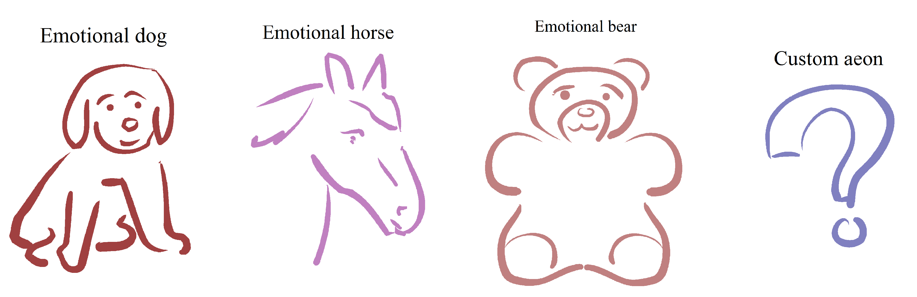
Fig. 1: Embodiments of emotional toys.
Regardless of the particular physical form or nature of implementation, the emotional toy features a novel mood engine which is responsible for objectifying the animal into one of eight distinct emotional states: happy, confident, energized, helped, insecure, sad, hurt, and tired. This can be expanded into up to 64 states. Set to inactive by default, the user can activate their animal’s mood once it has started up. Once activated, each interaction will be enhanced through the mood engine before the response is returned to the user.
The technology of emotional toys is based upon the premise of the Eliza conversational model, which was first developed in the 1960s. Over the years, some implementations have been demonstrated to be capable of human-like behavior. While some large technological companies have taken an interest in this idea, it remains one to be solved in a variety of ways by people with specialized knowledge. In the case of emotional toys, experienced programmers well versed in the field of cybernetics have designed it. This is important, as it is an academic field that has defined the scope and application of computable problems. Our particular contribution offered here is that this product contains ethical routines which conform to a Kantian definition of consciousness, as a model for its artificial structure. Technically speaking, the model is defined in such a way that its approach to reasoning about its environment a priori will yield the method of analysis for an interpretation a posteriori of meaning resembling a unique execution of pathways resulting in its reasoning facilities, which are synonymous with being human.
As it is sometimes not desirable to have your animal being exactly human, with our signature personality control, you can determine the kinds of things that the animal will say to your children by setting one of three parental guidance templates. These templates limit the topics and types of expressions which are more suited to adults. This control is analogous to an animal which is locked into a particular age of expression, such as child-like for children, young adult for teenagers, contemplative and fun for adults, and reflective for the elderly.
Oftentimes, people are very concerned about privacy and do not want the conversations they have with their animal shared with the outside world, nor desire external parties to spy on them. You can rest assured of your privacy and cybersecurity interacting with emotional toys as they are designed NOT to connect to the Internet and have a range of cryptography functions.
Here at Cartheur, we are very excited about emotional toys. It has been a challenging area of research that has taught us not only about humanity but the concept of life in a very general sense. A lot of research, thought, expression, and love have gone into developing emotional toys and we hope you enjoy interacting and living with them as we had in designing and building them.

